Course Name: | Artificial Intelligence Laboratory | Semester: | VI
Date of Performance: | 11 / 04 / 26 | DIV/ Batch No: | A1
Student Name: | Aaryan Sharma | Roll No: | 16010123012

Experiment No: 6

Title: Implementation of alpha-beta pruning

Aim: Implementation of Adversarial Search Algorithm - Alpha-Beta Pruning

Objectives of the Experiment:
By the end of this experiment, students will be able to:
- Students will be able to implement and analyze the Alpha–Beta Pruning algorithm to optimize game tree search and improve decision-making efficiency

COs to be achieved:
CO2: Analyze and solve problems for goal-based agent architecture (searching and planning algorithms)

Books/ Journals/ Websites referred:
- https://www.geeksforgeeks.org/artificial-intelligence/alpha-beta-pruning-in-adversarial-search-algorithms/

Theory:
Alpha–Beta Pruning is an optimization technique used with the Minimax algorithm in game-playing scenarios such as Tic-Tac-Toe, Chess, and Checkers. The Minimax algorithm evaluates all possible moves in a game tree to determine the optimal decision for a player. However, this approach is computationally expensive as the number of nodes grows exponentially.

To overcome this limitation, Alpha–Beta Pruning reduces the number of nodes evaluated by eliminating branches that cannot influence the final decision.
Working Principle: The algorithm uses two values:
Alpha (α): The best value that the maximizing player (MAX) can guarantee so far.
Beta (β): The best value that the minimizing player (MIN) can guarantee so far.
During the traversal of the game tree: If at any node, the condition α ≥ β is satisfied, further exploration of that branch is stopped. This is because that branch will not produce a better outcome than already explored options.
Adversarial Search Concept:
Used in two-player competitive games
One player tries to maximize score (MAX)
Other tries to minimize score (MIN)
Examples: Chess, Tic-Tac-Toe
Uses game tree

Alpha-beta pruning algorithm:
Begin with α = −∞ and β = +∞
Evaluate nodes using depth-first search
At each level:
- MAX tries to increase α
- MIN tries to decrease β
If at any point:
α ≥ β → prune remaining subtree
Continue until reaching leaf nodes or pruning occurs
Final value at root = optimal decision

Chosen Problem:
Determine the best move for a player in a Tic-Tac-Toe game using Alpha–Beta Pruning.

Solution tree for chosen Problem:
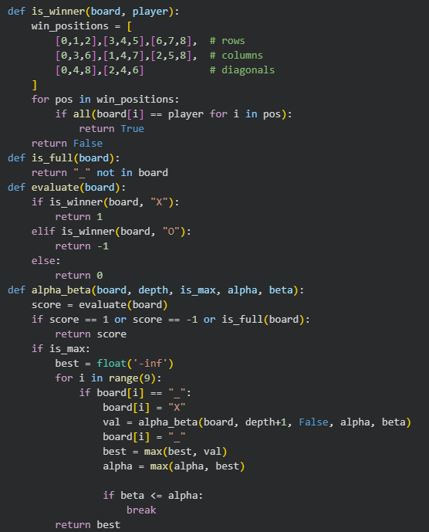

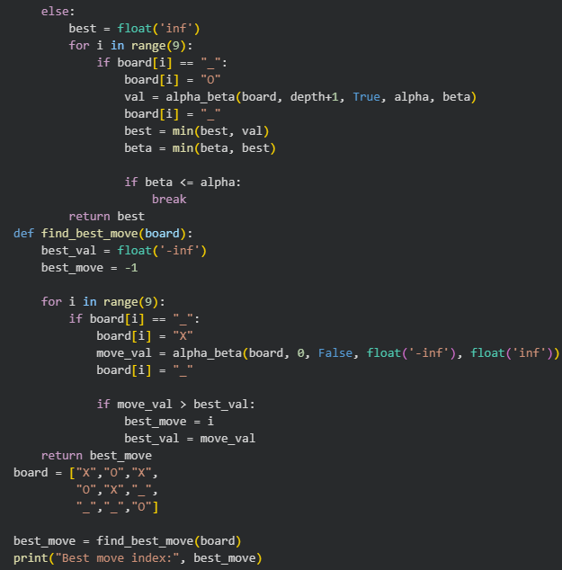


Post Lab Subjective/Objective type Questions:
- Does Alpha–Beta pruning affect the final decision of Minimax? Explain.
No, Alpha–Beta pruning does not affect the final decision of the Minimax algorithm. It only reduces the number of nodes evaluated by pruning unnecessary branches, while still ensuring the same optimal result as Minimax.

- In which types of problems is Alpha–Beta pruning commonly used?
Alpha–Beta pruning is commonly used in adversarial search problems such as two-player games like Tic-Tac-Toe, Chess, and Checkers, where one player tries to maximize the score and the other tries to minimize it.
- How does the order of node evaluation affect the efficiency of Alpha–Beta pruning?
The efficiency of Alpha–Beta pruning depends heavily on the order of node evaluation. If the best moves are evaluated first, more branches are pruned, leading to faster performance. Poor ordering results in fewer prunings and reduced efficiency.

- What is the best-case and worst-case performance of Alpha–Beta pruning?
In the best case, Alpha–Beta pruning reduces the time complexity from O(b^d) to approximately O(b^(d/2)), making it much faster. In the worst case, it behaves like the standard Minimax algorithm with complexity O(b^d), where no pruning occurs.

Conclusion:
This experiment successfully demonstrated the implementation of the Alpha–Beta pruning algorithm to optimize the Minimax search in a game-playing scenario. The experiment showed how pruning reduces the number of nodes evaluated without affecting the final decision. It improved understanding of adversarial search, decision-making strategies, and the importance of efficient search techniques in AI applications.

